# École Alvin Buckwold School Reopening Plan

## Dear Parents and Caregivers of École Alvin Buckwold School students,

Our staff is excited to welcome you and your children back to school in the coming weeks. Our staff have worked together over the past three days and will continue to work together to ensure we can safely reopen our school. We are confident that the plans outlined in this document will ensure a safe reopening. We were fortunate to have the Saskatoon Public Schools [Parent and Caregiver Reopening Handbook](https://www.spsd.sk.ca/division/reportsandpublications/Documents/Parent%20and%20Caregiver%20Reopening%20Handbook.pdf) to guide our plans, which will also provide you with information on how our school is planning to open safely for your children.

The Saskatoon Public Schools handbook provides detailed information on many important topics including:

* Safety Precautions
* Curriculum and Assessment
* Support Services
* Food and nutrition programs
* Facilities
* Students

The guidelines of the Parent and Caregiver Handbook will be adhered to by our school along with additional specific elements that are described below.

Tomorrow teachers from École Alvin Buckwold school will be contacting each family to welcome you back, ease your concerns and inquire about your plans for returning to school.

**The following information represents our school specific plan for a safe return to school at École Alvin Buckwold. Please note that the plan is subject to change at any time based on direction from Saskatchewan’s Chief Medical Health Officer. Changes may also be made by school administration as revisions are required. Changes will be communicated as they occur.**

## Safety precautions regarding Illness

* As explained in the Parent and Caregiver Handbook, we will strictly monitor student and staff health.
* If your child is experiencing any COVID-19 symptoms (see page 8 of the [Parent and Caregiver Reopening Handbook](https://www.spsd.sk.ca/division/reportsandpublications/Documents/Parent%20and%20Caregiver%20Reopening%20Handbook.pdf) for details), do not send your child to school. Contact Healthline 811 for assistance. Call the school at 306-683-7100, email [alvinbuckwoldschool@spsd.sk.ca](mailto:alvinbuckwoldschool@spsd.sk.ca) or report the absence on School Messenger <https://go.schoolmessenger.com> to let us know that your child is ill.
* Parents and caregivers should make a plan in case their child needs to be picked up early from school due to illness. Please ensure contact information is up to date with the school.
* We will require parents to pick up their child if they exhibit **any symptoms of COVID-19 while at school.**
* Children exhibiting symptoms of COVID-19 will be removed from their classroom to wait in the isolation room, referred to in the Parent and Caregiver Handbook.
* The isolation room at our school will be in Mme Kathy Kruger’s office (our Vice Principal), which is the first office to your left as you enter the front doors of our school.
* While in the isolation room, children in kindergarten to grade 8 will be given a disposable mask, if they do not have one of their own, to wear until their parent arrives to take them home.
* Children will be spaced 6ft apart if there needs to be more than one child in the isolation room.
* If additional isolation rooms are required, these will be found close to the office (ex. Staffroom, Mr. Simpson’s office, band room).

## School day schedule

* Our bell times are the same as last year for the start of the day, end of the day and lunch break. These are as follows:

8:35am Warning Bell

8:40am School day begins

11:30am Lunch begins

12:20pm Lunch ends

3:05pm End of school day

* We would ask parents, that are not sending their children on the bus, to have their children arrive as close to 8:35am as possible.
* Supervision is provided in our school yard from 8:25 to 8:40am and 3:05 to 3:20pm

## Recess

* Recess at École Alvin Buckwold School will look different this year.
* Homeroom teachers will embed recess into their schedule. This could look like a traditional recess where students play outside, or they may do other movement breaks outside or inside the school.
* These breaks will either be with the students’ own class or within a cohort of two classes, which will remain consistent all year.
* The school yard will be divided into zones to ensure that each 2-class cohort has their own space to play, where they will not interact with any other students. Throughout the week students will have an opportunity to play in a variety of zones.
* Individual classrooms will be assigned specific doors in our school for entry and exit.
* Teachers will ensure staggered entry and exit during all entry/exit times during the day. This will ensure each class moves through the doors and hallways without mixing with other classes.
* Students will hand sanitize upon entry and exit of the school.

## Lunch

* Students are encouraged to go home for lunch when possible.
* Students heading home at lunch will leave through their assigned door. If they are meeting a sibling, please choose a meeting place for your family in the school yard.
* Students should return from lunch at 12:20pm.
* Students in the primary grades will play outside during the first half of lunch (11:30-11:55) and then will enter to eat (11:55-12:20).
* Students in the middle years grades will eat during the first half of lunch (11:30-11:55) and then go out to play (11:55-12:20).
* Students will remain in their 2-class cohort while playing outside. Staff supervisors will be on hand to ensure students stay in their assigned zone for that day.
* The divided lunch schedule allows us to reduce the number of students outside in our school yard at any one time. Students will rotate through the school yard zones, to ensure they get an opportunity to play in every area throughout the week.
* Students staying at school over the lunch break must eat in their classrooms at their desk.
* Students will be supported to sanitize their desk or lunch space prior to and after eating.
* Students will either wash their hands or hand sanitize prior to and after eating.
* Teachers will ensure staggered entry and exit at lunch. This will ensure each class moves through the doors and hallways without mixing with other classes.
* Children should bring any utensils they may require to eat their lunch and containers that they can easily open on their own.

## Entering the school

* Classroom teachers will have a muster point that will be communicated with families. This muster point will be used at the beginning and ending of every school day.
* Classrooms are assigned specific doors and entry and exit are staggered.
* All students and staff will sanitize their hands upon entry or at exit of the school.
* Children arriving at school after their class has entered from their muster points will be required to enter at the main doors and check-in at the office.
* School administration will follow-up with families when their child(ren) are late to help support on-time arrival so that they can enter with their class.

## Exiting the school

* Classroom teachers will accompany their class to the muster point at the end of the day.
* Classes will stagger their exit through assigned doors to ensure classes do not mix.
* We would like parents and caregivers to collect younger children from the muster points. Alternate plans can be communicated to the classroom teacher.
* Teachers will be supervising students at the muster points until 3:20pm, but we would prefer parents collect children as close to 3:05pm as possible. Parents are asked to come to their child’s muster point, if required, as parents/caregivers are not allowed to enter the school at this time for pick up purposes.
* Children that use active transportation (walk, bike, scooter, etc.) will be dismissed from their muster point at 3:05pm.
* Children using the bus will be sent to the bus loading area at 3:05pm from the muster point.
* Children that are not picked up by 3:20pm will be brought to the front of the school and administration will contact the parents.

## Bussing

* Please refer to page 14 in the [Parent and Caregiver Reopening Handbook](https://www.spsd.sk.ca/division/reportsandpublications/Documents/Parent%20and%20Caregiver%20Reopening%20Handbook.pdf) for details on bussing.
* Children that arrive on the school bus will head from their bus to the muster points upon arrival.
* Staff supervisors will be present to help children get off the bus and make their way to their teacher’s muster point.
* At the end of the school day, children using the bus will be sent to the bus loading area at 3:05pm from the muster point.
* Staff supervisors will be present to help children make their way from their teacher’s muster point to the bus loading area.
* Parents or caregivers will be called if a child misses the bus.

## Parking and student drop-off/pick-up

* Until we have a better understanding of the number of parents driving their children to school, we would ask parents to use the alley along the west side of our park as a drop off zone.
* Please do not use the alley to the east side of our school (adjacent to the staff parking lot and Eastview Early Learning Center).
* Please help us to keep all children safe by not parking in the alley but stopping to let your children out and then continuing south past our park. For the safety of the students and drivers, please enter from East Drive and you will exit either onto Louise Street or East Place.
* We will have staff supervisors on site to help your child(ren) get to their muster points with their teacher.
* If you would prefer to park and walk your child to the muster point, please find a safe parking spot in the neighborhood. We do have a supervised crosswalk directly across from the front doors of our school.
* Buses will be parked in front of our school for a longer period of time in the morning to facilitate bus sanitization after drop off. This cannot be used as a drop off location.
* Please remember to honour the city and school bylaws and parking restrictions for student safety (ex. No U-turns in a school zone, no stopping on the crosswalk, no stopping in driveways, no stopping in bus zone)

Staggered Start

* École Alvin Buckwold School will have a staggered school reopening during the week of September 8th to 11th.
* Kindergarten students will be informed of their half day staggered start directly from their teacher tomorrow. These half days will be between Tuesday, Sept. 8th to Friday, Sept. 11th.
* Students in grade 1 to 8 with a last name that begins with the letter A to L will attend on Tuesday, Sept. 8th and Thursday, Sept. 10th
* Students in grade 1 to 8 with a last name that begins with the letter M to Z will attend on Wednesday, Sept. 9th and Friday, Sept. 11th.
* Busses will be running during staggered start for children that are in grades 1 to 8 and already registered on the bus.
* Kindergarten busing begins on Monday, September 14th, they do not have bussing during staggered start.

## Storage of student materials

* Classroom teachers will have plans for the storage of student materials and supplies that ensure student items are kept separate.
* Please send school supplies during your child(ren)’s staggered start day. These will be kept at school.
* At this time, we will not be using lockers in the hallways of our school. The use of lockers increases congestion, student mingling, and touch points. Students will bring their jacket and backpack to their classroom daily.
* Individual lockers inside of classrooms will be used for outdoor clothing and backpacks and staggered access will be managed by teachers.
* Our primary students have traditionally stored their backpacks and jackets on hooks along the primary hall. Staggered access will be managed by teachers.

## Flow of traffic through the school

* Directional arrows will guide our traffic flow through the hallways and in our classrooms.
* Teachers will support students to learn these new routines during the first weeks of school.
* Teachers will accompany students as they move from their classroom to the music room, gym or library. This will ensure organized and safe movement within our school.
* Social distance markers will also be used on our floors where needed, to ensure student and staff distancing.
* All interior doors will be propped open to minimize touch points and ease the flow of traffic.
* Doors will be marked with enter and exit signs where appropriate.

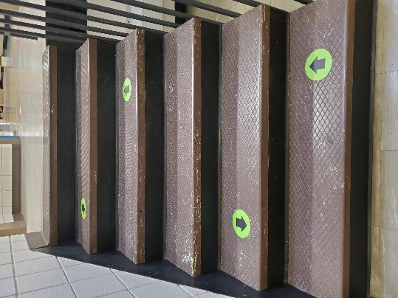 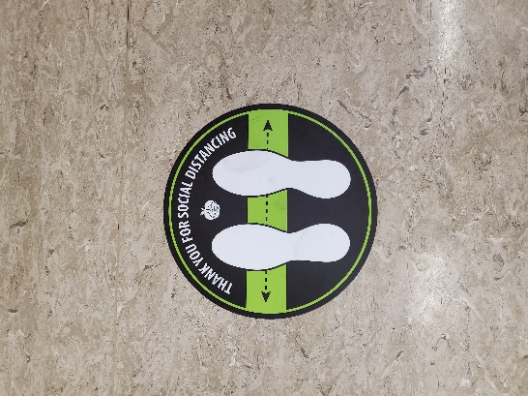 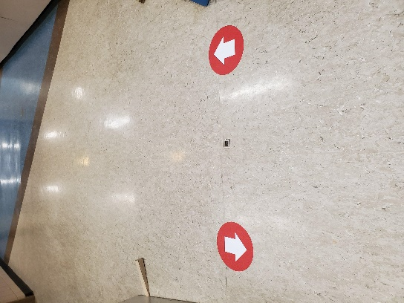

## Parent/Caregiver access to school

* Parents/caregivers are encouraged to contact the main office to make an appointment if they need to come to the school. At this point, we request that this occur only if necessary.
* Hopefully, most communication can occur outside at the muster points or via email/phone call. If you need to come into the school, you will need to complete the QR code health questionnaire posted on the front doors of our building (paper copies will be available at the office). A free QR scanner app can be downloaded to your phone, alternately many cell phone’s cameras can automatically scan this code to bring up the health questionnaire. Please check your cell phone settings to allow this feature.
* If an appointment is required please phone the front office at 306-683-7100 or email [alvinbukcwoldschool@spsd.sk.ca](mailto:alvinbukcwoldschool@spsd.sk.ca)
* Parents are required to wear a mask and hand sanitize when entering the school.
* As the school year begins, most communication will happen via the teacher. Classroom teachers will be providing you with their direct email address and they can always be reached by phone at the school number.

## Eastview Early Learning Center (Lunch Program, Before and After School Program)

* Eastview Early Learning Center will communicate their specific protocols, but we are working together to ensure consistency for our families and students.
* Staff from the center will help school aged children, attending the before school program, make their way to their teacher’s muster point each morning.
* Teachers will send children that are registered with the after-school program to the gym, where Eastview Early Learning Staff will be waiting.
* Children that are registered for the lunch program at Eastview Early Learning Center, will be dismissed from their classroom at 11:30 to make their way to the program area. The students will be sent back to their class at 12:20pm for their afternoon of learning.

## Hygiene

* Students will be taught and expected to follow proper hand hygiene. This includes washing hands with soap and water for at least 20 seconds and/or the frequent use of hand sanitizer. Visual instructions for proper hand washing will be displayed beside every sink.
* Hand sanitizer will be available in all schools at all entrances and in every classroom. Students are encouraged to bring their own bottle of hand sanitizer (scent free whenever possible).
* There will be numerous prompts to wash hands or use hand sanitizer throughout the day, such as when first entering the building, entering the classroom, or using a shared material
* Classes will be assigned one of three washrooms in our building.
* Classroom teachers will have plans for the use of the washroom and water bottle filling stations to minimize traffic and congestion at the locations.
* Increased cleaning and sanitization will be scheduled in our washrooms.
* Please see page 30 and 31 of the [Parent and Caregiver Reopening Handbook](https://www.spsd.sk.ca/division/reportsandpublications/Documents/Parent%20and%20Caregiver%20Reopening%20Handbook.pdf), for details regarding the sanitization process in our schools.
* Staff will support students in sanitizing shared technology between student use.
* Students are required to bring a filled water bottle from home. This should be labelled with their name. As we have only two water bottle filling stations in our school, if you believe your child consistently requires more than one bottle full of water per day, we recommend sending two.
* Water bottles will be sent home daily to be cleaned and refilled.
* We will have disposable water bottles at the office for any children that forget their water bottle.

## Mask usage

* Grade 4-8 students are required to wear masks when appropriate physical distancing cannot be

maintained.

* Masks are recommended for kindergarten to Grade 3 students.
* Staff are required to wear masks at all times when appropriate distancing cannot be maintained.
* When physical distancing is achievable, mask breaks may occur (i.e. outdoor learning).
* All students are required to wear masks while riding the bus.
* All visitors must wear masks.
* Saskatoon Public Schools will provide one reusable mask for each student. Additional disposable masks will be made available to students when needed and required.
* Please ensure all masks are labelled with your child(ren)’s names.
* Students are welcome to bring their own masks.
* In some situations, wearing a mask may not be possible for a student. In these instances, school staff members will work with parents/caregivers to consider accommodations. More information can be found on the [CDC website](https://www.cdc.gov/coronavirus/2019-ncov/prevent-getting-sick/cloth-face-cover-guidance.html#feasibility-adaptations).
* Staff members will be provided with a reusable mask and face shield for use as needed. Staff members may also choose to use their own mask.
* More information about the proper usage of masks or face coverings is available from the [Public Health Agency of Canada](https://www.canada.ca/content/dam/hc-sc/documents/services/publications/diseases-and-conditions/covid-19-safely-use-non-medical-mask-face-covering/covid-19-safely-use-non-medical-mask-face-covering-en.pdf). “

## Mental Health and Social-Emotional Supports

* Children who need additional support for their well-being may receive support from the school counsellor. This occurs in consultation with parents.
* Parents who believe this support may be necessary can reach out to their child’s teacher or administrator to discuss this support.
* The counsellor will work with the team to determine appropriate supports, which may include direct support and/or assisting students and families to access other services in the community.
* Well-being is one of our four student goals in our school division strategic plan. Opportunities to learn about and practice well-being exist across multiple curricular areas.
* Our teachers will ensure that all children feel as comfortable as possible while re-entering school with these new routines. They will focus on developing a sense of belonging, as we know this facilitates successful learning.
* Communication is key to ensuring the successful reopening of school for your family. Please contact your child(ren)’s teacher with any concerns about your child’s wellbeing.

We will be providing parents and caregivers an optional opportunity to ask questions or seek clarification on any part of this plan through a virtual (Zoom) Question and Answer session. This session is being offered tomorrow, Thursday, August 27th from 5 to 6pm. If you are interested in attending please email [hynesl@spsd.sk.ca](mailto:hynesl@spsd.sk.ca) with your question(s) and we will provide you with the zoom link. We would prefer to have the questions ahead of time to group them by topic and to ensure we cover all questions in the hour provided.

Parents can expect to receive a phone call tomorrow morning from one of our teachers. This will also provide you with an opportunity to ask questions or share concerns regarding the school plan.

We are excited to learn with you throughout the 2020-2021 school year. We know this is a different school year start-up and we’ll have less opportunities to see you face to face, but our priority continues to be open communication and parental involvement.